**How Siri works**

1. When your order Siri to perform an action, it records the frequencies and soundwaves from your voice and converts them into a code.
2. Siri then breaks down the code in context to identify patterns and keywords.
3. This data gets input into an algorithm and is then matched against thousands of combinations of sentences to identify what your phrase means.
4. The algorithm then determines the context of your sentence through working around various literary expressions.
5. When Siri understands your request, it begins to assess the tasks that need to be performed.
6. In the previous step, Siri also determines whether the required information is available within the phone’s data bank or has to be extracted from the world wide web.
7. At last, Siri is able to answer your question forming complete and cohesive sentences

**NATURAL LANGUAGE PROCESSING**

Natural Language Processing is a branch of artificial intelligence affiliated with giving computers the ability to understand text and spoken words just like a human being would.

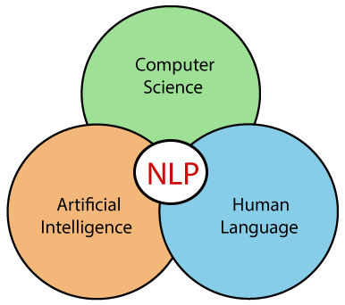

Human language is too sophisticated and ambiguous to write software that accurately determines the intended meaning of text or voice inputs. This is because of the irregularities of human language such as homonyms (words with similar pronunciations or spelling but different meaning), grammar variations in sentence structure, sarcasm, idioms, metaphors and other figures of speech. The meaning of a word greatly depends on the context in which it has been used.

*Natural language processing strives to build machines that understand and respond to text or voice data—and respond with text or speech of their own—in much the same way humans do. –* ***IBM***

Natural Language Processing mainly explores two ideas:

1. **Natural Language Understanding** - This is concerned with how we get meaning out of combinations of letters. Natural Language Understanding helps the machine to understand human language by extracting metadata from content such as keywords, emotions and relations from the user's input

2. **Natural Language Generation** - This is concerned with how to generate knowledge from language. This serves to translate computerized data into natural language representation.

**Working Mechanism of Natural Language Processing**

There are five steps in Natural Language Processing

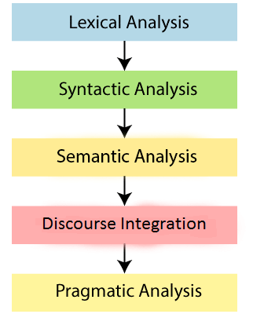

**1. Lexical Analysis and Morphological**

This phase involves dividing the whole statement as received from the user into words.

Example:

The statement “Mary is a girl” is broken down into “Mary”, “is”, “a” and “girl”.

**2. Syntactic Analysis (Parsing)**

Syntactic Analysis is used to check the grammatical correctness of the sentences.

Example:

The statement “Boy the goes to store” will be rejected since the determiner “the” comes after the noun “boy”.

**3. Semantic Analysis**

This is concerned with perceiving the meaning of a statement. A sentence may be syntactically be correct but does not make perfect sense

Example:

The statement “She is wearing a colorless green dress” seems grammatically correct but how can a dress be green and colorless at the same time.

**4. Discourse Integration**

This involves finding dependencies such as pronouns and understanding where the dependency is pointing to.

Example:

In the statement, “Rob is a scout; he often goes camping often”, “he” is a dependency pointing to Rob

**5. Pragmatic Analysis**

This phase deals with the context of a sentence. Whatever was said is re-interpreted on what it actually meant. It involves deriving those aspects of language which require real world knowledge.

Example:

In the statement “John saw Mary in a garden with a cat” we cannot properly deduce whether Mary is in the garden with the cat or John is the one in the garden with the cat